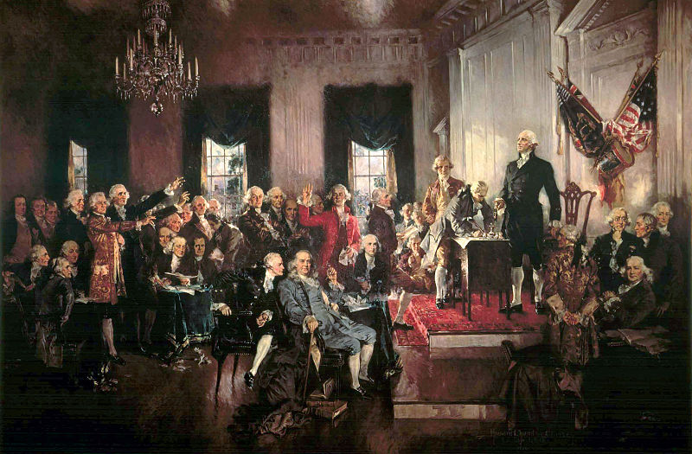

In 1783, the British General Cornwallis surrendered after their defeat at the Battle of Yorktown. The American Colonies were now the United States. What is the first thing any new nations needs? A government.

Without getting bogged down in too many details I’ll summarize it this way: The first government of the United States of American was the Articles of Confederation. By design, the Articles was incredibly weak and allowed each state to virtually govern itself. In this sense, it created thirteen separate nations all of whom agreed to sort of work together. Under the Articles of Confederation, there was very little unity or national identity. The laws in New York were vastly different from those in say, Virginia. In 1787, the Founders understood this was not a viable government and to move forward they needed a stronger central or federal power.

Men such as James Madison, Ben Franklin, Thomas Jefferson (who was in France, but corresponded through Madison), Alexander Hamilton, George Mason, James Monroe, George Washington and others met in Philadelphia to draft a new constitution. At the Constitutional Convention they debated many issues such as the power of the federal government, the continuation of slavery, state representation, interpretation of law, the balance of stability and authority versus liberty and so on. They feared that creating a strong federal government would foster the conditions of tyranny, yet they also feared that a weak federal government would enable near anarchy in which powerful states would overwhelm the smaller ones.

The basic issue was that the Federalists believed it was crucial to have a strong national government and each state should only have a limited ability to enact its own laws. They felt one nation should have one principle set of laws. The Anti-Federalists did not see it that way. In their view, states should have a say in how they government their citizens. The economies, cultures, geographies, and attitudes of each state differed and according to the Anti-Federalists, the laws should also have differed. The result was a series of compromises.

Use the “The Constitutional Convention Begins” History Page, the various links therein and/or the Experience History, Chapter 8: Crisis and Constitution to answer any five of the questions below. Each response should be approximately three-five sentences, based on historical research and must be cited. ANY plagiarism will not be tolerated. These are worth two points each.

https://www.history.com/this-day-in-history/constitutional-convention-begins

As always, type the question prior to answering it.
- What was the general ideologies of the Federalist Part and the Anti-Federalist Party?
- Why did the Anti-Federalists fear a powerful federal government?
- Why were the Federalists concerned about granting too much authority to the states?
- What was the compromise of large state/small state representation in Congress?
- Why did the Founders largely ignore the issue of slaver?
- How does the federal government check and balance its own authority?
- The Constitution is a “living document.” What does that term mean?
- Explain the significance of the Bill of Rights
- What mistakes did the Founders make when they drafted the Constitution?

The assignment is due Sunday, July 18th at 11:59 PM

